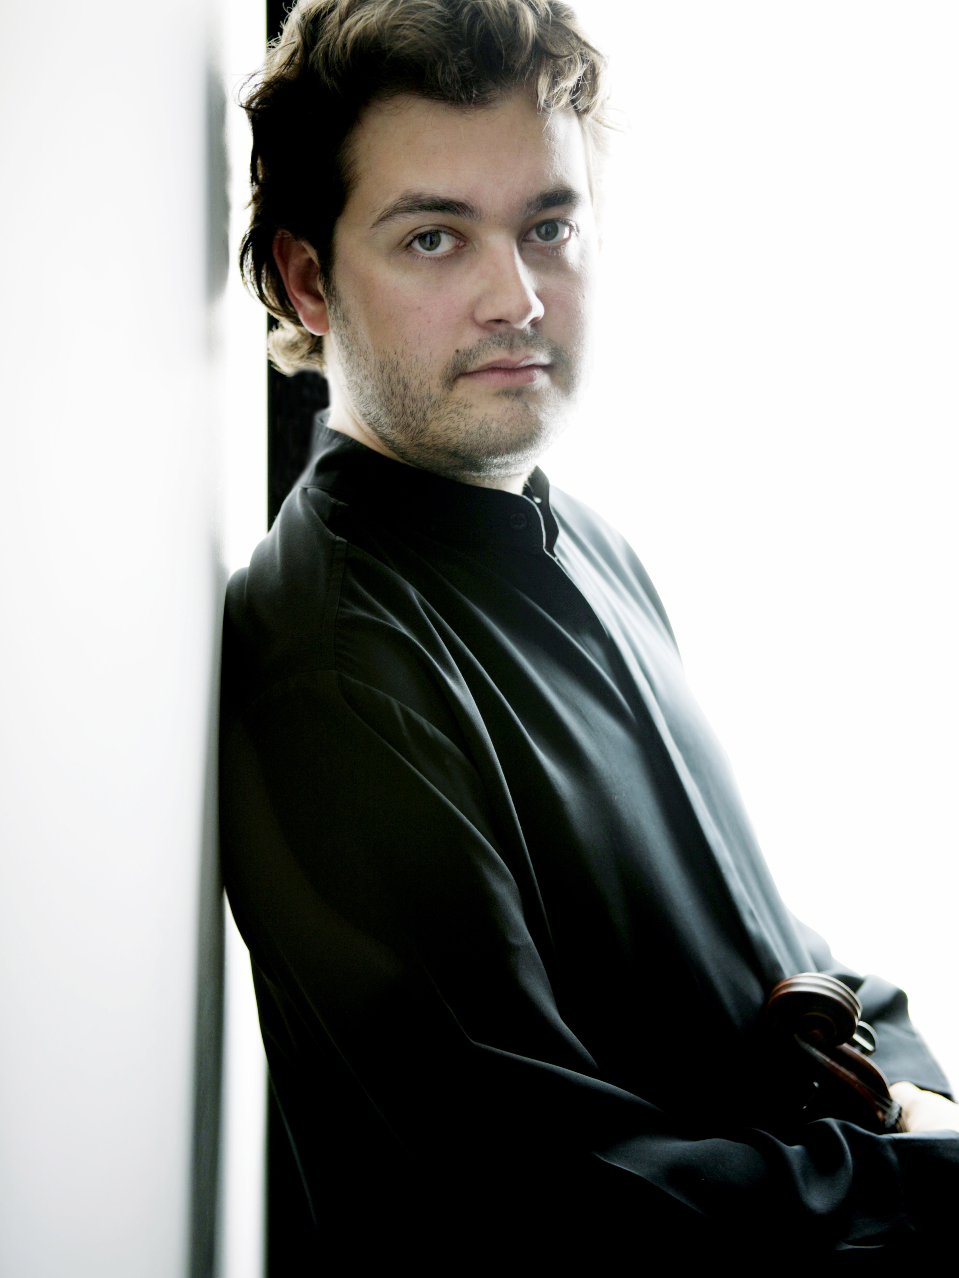
Lawrence Power - viola

Lawrence Power is one of the foremost violists today. After winning prizes at many international competitions, including the Maurice Vieux Viola Competition in Paris and becoming the first British winner of The William Primrose International Viola Competition, Canada, he was selected for the BBC 'New Generations' Scheme which led to numerous broadcasts in recital and as a soloist with the BBC Orchestras.

Since making his debut as soloist with The Philharmonia in London, he is highly sought after in the UK and abroad, appearing as soloist with orchestras such as The London Symphony Orchestra, BBC Symphony, BBC National Orchestra of Wales, BBC Scottish, Royal Liverpool Philharmonic, Norwegian Radio, City of Birmingham Symphony Orchestra, Verbier Festival Chamber Orchestra, Lucerne Festival Strings, Musica Vitae Chamber Orchestra (Sweden), The English Chamber Orchestra, Scottish Chamber Orchestra, Center Symphony of New York and New Zealand Symphony, performing with various conductors including Oliver Knussen, Frans Bruggen, Leonard Slatkin, Ilan Volkov, Martyn Brabbins, James Judd, Gerard Schwartz and Jan Pascal Tortelier. He has recently appeared as soloist at the BBC Proms; the Barbican, London; Birmingham Symphony Hall; the Concertgebouw, Amsterdam; Mann Auditorium, Tel Aviv and Jerusalem Theatre. He is also committed to expanding the viola repertoire and has given the world premieres of many pieces written for him, including works by Sally Beamish, John Kaefer, Colin Matthews, Mark-Anthony Turnage and Andrew Toovey, and Huw Watkins. In addition to his solo career he is much in demand as a chamber musician being violist in both the Nash Ensemble and the Leopold String Trio (recent recipients of the 2005 Royal Philharmonic Society Chamber Ensemble Award), and he is a frequent guest at international music festivals such as Verbier, Vancouver, Oslo, and Edinburgh, Aldeburgh and Cheltenham in the UK.

His recent world premiere recordings of concertos by Cecil Forsyth and York Bowen (BBC Scottish Symphony Orchestra/Martyn Brabbins) for Hyperion Records was widely praised and chosen by Gramophone as both the “Critic’s Choice” and one of the best hundred CDs of 2005. This year Hyperion will release the Brahms Viola Sonatas and both the Walton and Rubbra Viola Concerti, and EMI will release his recording of Mozart’s Sinfonia Concertante with Maxim Vengerov and the UBS Verbier Festival Chamber Orchestra.

This season he has performed the Walton Concerto with the BBC Scottish Symphony Orchestra, Mozart’s Sinfonia Concertante with the Lucerne Festival Strings in Lucerne and Zurich, and a new concerto by Sally Beamish with the Scottish Ensemble. He will also tour Europe and North America with Maxim Vengerov and the Verbier Festival Chamber Orchestra with concerts in New York, Vienna, Amsterdam, Dublin, Birmingham, Glasgow, Birmingham, London and Toronto. This summer he returns to the Verbier Festival and the BBC Proms. Future engagements include the York Bowen Concerto with the Philharmonisches Staatsorchester in Mainz, the Mozart Sinfonia Concertante with Elisabeth Batiashvili with both the Symphonieorchester des Bayerischen Rundfunks and the Royal Stockholm Philharmonic, the Miklos Rozsa Concerto with the Royal Liverpool Philharmonic and Paul Daniel, and the Bartok Concerto in Amsterdam with the Royal Concertgebouw Orchestra under Markus Stenz.

Lawrence Power plays a rare viola by the Bolognese maker Antonio Brensi from c.1610 and is fortunate to have had the support of the Nigel Brown instrument scheme in order to secure its purchase.

