Daria La Barbera

MISTAKEN IDENTITY

IN SHAKESPEARE’S COMEDIES

INTRODUCTION

The aim of this essay is to present how Shakespeare deals with mistaken identity in his plays.
Wordsworth once wrote "the Child is father of the Man."( “My Heart Leaps Up When I Behold” verse 7). Wordsworth referred to the Bible, but this seemingly contradictory statement is truly evidenced in the work of William Shakespeare. From the early comedies through the histories, tragedies, and eventually into the romances, Shakespeare frequently dealt with recurring subject matter using similar devices; however, his handling of this material demonstrates his progressively maturing grasp of the dramatic medium. This can be demonstrated by pursuing Shakespeare's development of the mistaken identity motif.
Shakespeare's recurring subject is clearly shown in the two comedies The Comedy of Errors and Twelfth Night where he manages to take the main idea of mistaken identity and expand it to go into his characters.

The Comedy of Errors and Twelfth Night

The ploy of mistaken identity as a plot device in writing comedies dates back at least to the times of the Greeks and Romans in the writings of Menander and Plautus. Shakespeare borrowed the device they introduced and developed it into a fine art as a means of expressing theme as well as furthering comic relief in his works.
In any case, the English playwright made a number of changes to the original story, including the addition of a second set of identical twins (the Dromios), to increase the confusion and the comic element, the expansion of Adriana's character and the creation of her sister, Luciana, and, finally, the creation of the back-story involving Egeon and Emilia. The play also draws on a number of other sources, for example, the lock-out scene, where Antipholus of Ephesus is locked out of his home for dinner, resembles a scene in another Plautine work, Amphitruo. The twin masters and twin servants in The Comedy of Errors (1590-94) are often played as mirror images of each other, at least in appearance. The script even gives them the same names: Antipholus of Syracuse and Antipholus of Ephesus; Dromio of Syracuse and Dromio of Ephesus. Why? Nobody could mistake them for each other if they answered to two different names. The only plausible explanation for this unrealistic touch, is that Egeon believed his older son, Antipholus of Ephesus, to be dead along with his servant; therefore he renamed the younger son and his servant for their deceased siblings. Although the comedy is slight on thematic content, one major idea that emerges from the script and converges with the twin characters in the plot is the tension between illusion and reality. Through the mistaken identity, we can see the difference between what a person appears to be and what he is in reality, as the appearance in contrast with reality theme. When a person mistakes appearance for reality, conflict and disorder follow.
When mistaken identity has been an issue, Shakespeare's comic resolutions work out very quickly in the play's final scene. In The Comedy, for example, once the abbess brings together the two long-separated sets of twins, all identities become clear, and reunion and restoration follow. In the romantic resolution the Antipholus twins are not only reunited as brothers; they are set to become brothers-in-law as well.
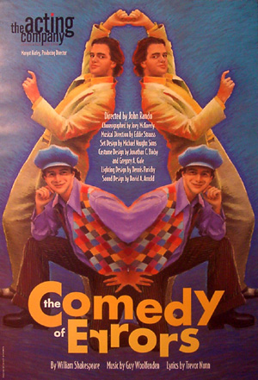
What makes this comedy so wonderful is that not only does Shakespeare maintain the comical aspects of it, but he gradually increases the tension. At first, the 'errors' only lead to private and comical misunderstandings. But later, more outside parties get involved as both Antipholuses and Dromios are mistaken for their twins (picture: The Acting Company production Art by Scott McKowen). Later, Antipholus of Ephesus suspects that his wife is having an affair. Soon, the errors lead to Antipholus of Ephesus and his friend Angelo getting arrested. And by the end of the fourth act, the confusion and errors have gotten so intense and out of hand that several characters in the play are angry at each other, and not one or two, but several of the characters are in danger of being physically hurt.
Several years later Shakespeare again used twin characters to complicate the plot of Twelfth Night (1601-02), a romantic comedy with melancholy overtones. This third set of twins is comprised of a brother and sister, Sebastian and Viola. When Viola disguises herself as a male servant, comic mistakes of identity similar to those in the comedy ensue.
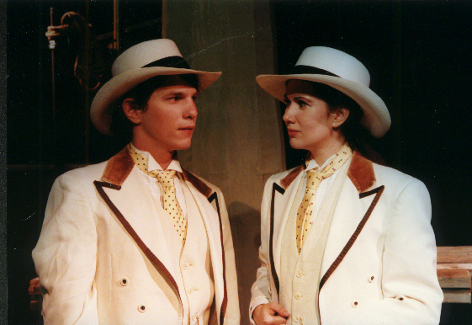
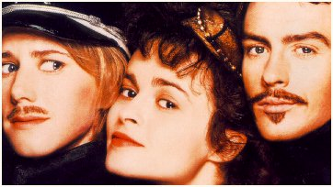
The instances of mistaken identity are related to the prevalence of disguises in the play, as Viola’s male clothing leads to her being mistaken for her brother, Sebastian, and vice versa. So, Sebastian is mistaken for Viola (or rather, Cesario) by Sir Toby and Sir Andrew, and then by Olivia, who marries him. Meanwhile, Antonio mistakes Viola for Sebastian, and thinks that his friend has betrayed him when Viola claims to not know him. These cases of mistaken identity, common in Shakespeare’s comedies, create the tangled situation that can be resolved only when Viola and Sebastian appear together, helping everyone to understand what has happened. The Comedy of Errors is also a source for Twelfth Night because of the use of twins and mistaken identity in the plot; though the major difference is that the twins in Twelfth Night are a boy and a girl (The twins Sebastian- Directed by Louis Leopardi) and therefore not completely identical, though their resemblance is used as a device in the plot. However, The Comedy of Errors is a more lighthearted work, that is more comedic in nature; Twelfth Night, though it is a comedy, delves more deeply into the grief of the twins, and into the emotional predicaments inherent in its plot.

CONCLUSION
Shakespeare was himself the father of twins, Judith and the son named Hamnet, born in 1585. Also if Shakespeare’s plays are not autobiographical, his experiences as the father of twins gives him special interest in the twin relationship. He must also have been influenced by the death of Hamnet in 1956, an even that occurred between the writing of his two plays that feature twins.
Through the analysis of these comedies, I found the comic element in Shakespeare. The comic always begins when a real situation changes. The characters, like in these comedies, play with dramatic and parody. The comic elements have the role to exalt and in the same time to deride the romantic aspects, also with farcical plots. Indeed, we always laugh when we watch or read these plays.
In these comedies, Shakespeare uses comic absurdities, trough the presence of the two twins, to explore profound human values and concerns. They are, above all, plays about identity, about knowing oneself in order to have satisfying relationships with others. "Who am I?" and "What is reality?" are universal themes in both tragic and comic drama. Shakespeare would return to these ideas and materials again and again in his works.

Web Sites & Pages
Page on a Web Site
Spark notes: Twelfth Night: Themes, Motifs & Symbols. 27 Dec. 2006, 2 Jan. 2007
<http://www.sparknotes.com/shakespeare/twelfthnight/themes.html>
http://www.sparknotes.com/shakespeare/errors/context.html

Enjoying "Twelfth Night" by William Shakespeare: Ed. Friedlander, M.D. 28 Dec. 2006, 2 Jan. 2007
<http://www.pathguy.com/12n.htm>

The Comedy of Errors: Books
http://www.amazon.com/Comedy-Errors-Folger-Shakespeare-Library/dp/0743484886

Reference Enciclopedia
The Comedy of Errors- Wikipedia, the free encyclopedia: 27 Dec. 2006.
<http://en.wikipedia.org/wiki/The_Comedy_of_Errors>

Books

Shakespeare, William. The Comedy of Errors Ed. Garzanti 1995 italian- english

Shakespeare, William. Twelfth Night Ed. Garzanti 2005 italian- english

Sparknotes: The Comedy of Errors: http://www.sparknotes.com/shakespeare/errors/context.html 27 Dec.2006, 2 Jan. 2007
http://www.bju.edu/campus/fa/cod/cp/comedy/
http://www.amazon.com/Comedy-Errors-Folger-Shakespeare-Library/dp/0743484886 28 Dec.2006
http://www.bju.edu/campus/fa/cod/cp/comedy/
5 http://www.bju.edu/campus/fa/cod/cp/comedy/
http://www.bju.edu/campus/fa/cod/cp/comedy

